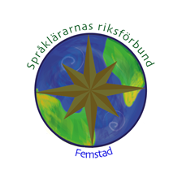
How to be Creative with Shakespeare
torsdag
26 september
Hjärtligt välkommen till en engelsklärarkväll med Shakespeare i fokus. Lisa Peter ger oss i två workshops tips om hur Shakespeare kan användas i undervisningen, med innehåll för såväl lärare på grundskolan som gymnasiet.

Plats: Agneberg (sal meddelas senare), Uddevalla
Datum: torsdag 26 september
Tid: 17.00 – 20.00

Pris: Är du medlem i Språklärarnas riksförbund 2019 är workshopen kostnadsfri. Anmälan är bindande. Om du efter anmälan önskar avanmäla dig måste detta ske senast torsdag 19 september via mail till mig. Annars tas en avgift på 150 kr ut.

Är du inte medlem för 2019 löser du medlemskap för 250 kr. Detta sker på plats via swish eller kontanter.

Program:
17.00 registrering och fika (fralla + kaffe/te/vatten)
17.30-18.30 Workshop 1: Shakespeare in the Language Classroom
Is it possible to teach Shakespeare to language learners? Aren't his plays and poems too old be studied in the 21st century? How can I approach his works in my classroom? These and more questions about how to include the world's most famous playwright in language teaching will be the topic for the first session. We will use a couple of sample activities to explore different avenues towards Shakespeare that work with lower secondary and upper secondary school students.
18.30-19.00 Fika (kaka + kaffe/te/vatten)
19.00 -20.00 Workshop 2: Shakespeare's Language (and how to deal with it)
This second session of the evening will focus on Shakespeare's language: the English he wrote in, the theatre he wrote for, and the verse and words he gave to his actors as well as his audiences. We will go through some close reading activities that will open up the texts to students not familiar with 16th-century writing for the theatre.

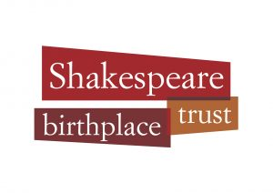
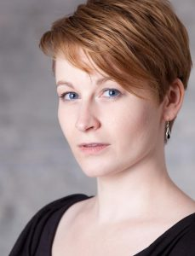
Lisa Peter, Senior Lecturer in Shakespeare Studies (International) and European Projects Manager at The Shakespeare Birthplace Trust. In her teaching at the Trust, Lisa particularly looks after international groups whose first language is any other than English, and she specialises in Shakespeare translations and the Shakespeare reception around the world. Her new range of educational sessions for language learners at the Trust was launched in 2015 and she co-developed the MOOC Exploring English: Shakespeare together with the British Council. In addition, Lisa contributed to the BBC Learning English series Shakespeare Speaks and she has written study guides for Digital Theatre Plus.

Du anmäler dig här. Sista anmälningsdag torsdag 19 september
Om du har frågor är du välkommen att höra av dig till undertecknad – Ulrika Arvidsson, ordf. lokalförening Femstad.

Välkommen!

